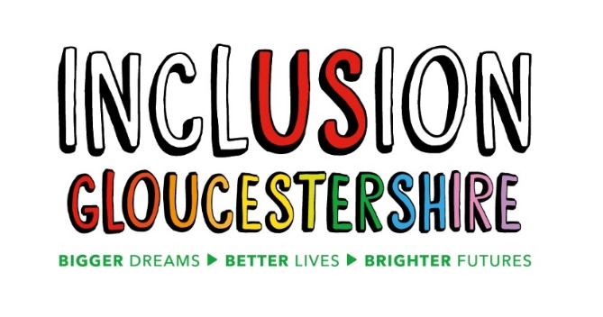

Expert by Experience to help with Co-Production

What is the job?
  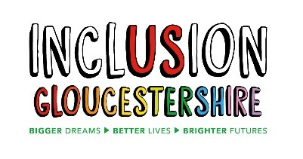   | Inclusion Gloucestershire are working with the NHS in the South West.  The NHS want to make sure they involve people with a Learning Disability and Autistic People in work to make things better.  This is called Coproduction.
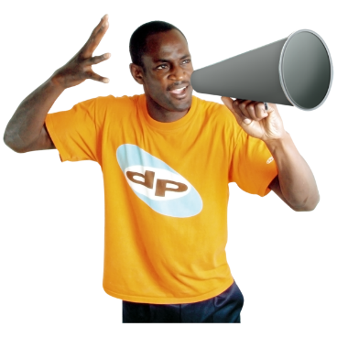 | You will be the voice of others with a Learning Disability and Autistic People.  You will speak up about things that need to be made better.
 | You will use your personal experiences to help with different projects.
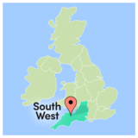   | We would like to give 5 people a Job.  These people can live anywhere in the South West.

Who will support me?
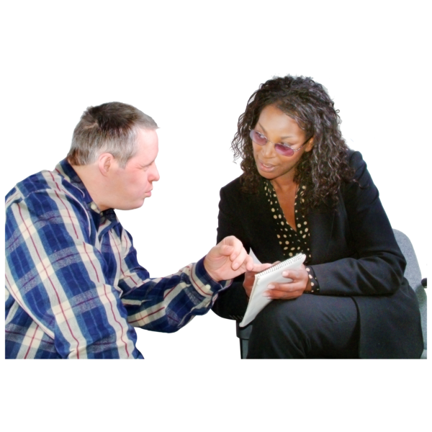 | A manager from Inclusion Gloucestershire will support you.  Someone from the NHS will also look at the work you are doing.

What do I have to do in this job?
   | Speak up about what people with a Learning Disability and Autistic People need.  You may need to write this down or speak in meetings.
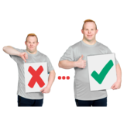   | Talk and listen to the NHS about ideas to make healthcare better.
 | Go to events and be part of coproduction groups to make sure everyone’s voice is heard.
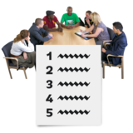 | Meet with the NHS and other professionals to give your feedback on work being done.  These meeting could be face to face or by video call.

What do you need to be able to do?
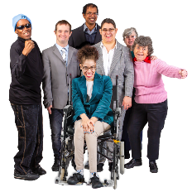 | You need to have a learning disability, be an autistic person or care for a person with a learning disability or an autistic person.
 | Be happy to talk in front of other people, including healthcare professionals.
 | You need to do what you said you are going to do.
 | You need to be able to work by yourself.
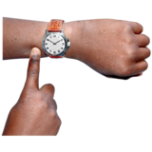 | Be good at being on time or doing something on time.
 | We need to trust you with confidential information
 | You need to be able to use the computer for:  - Emails  - Writing Notes  - Research on the internet
 | You need to know how to use Microsoft Teams and/or Zoom.
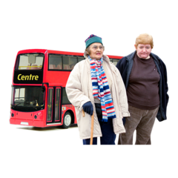 | Travel independently on public transport across the South West when needed.

Things that would be good to know about already
Working in Coproduction

Inclusion Gloucestershire believes all staff should
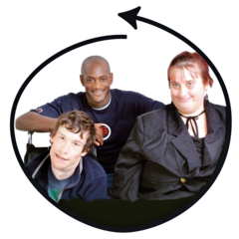 | Make sure everyone is included
 | Stand up for disabled people when things aren’t right
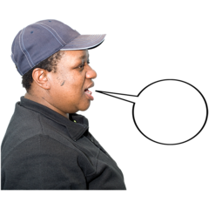 | Be fair and honest all the time
 | Be caring and professional
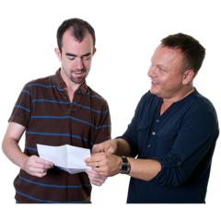 | Help each other to do exciting new things

Answers to questions you may have
 | You can work from anywhere in the South West  We hope to give the jobs to people from different counties in the South West.
 | We may ask you to travel to a meeting.  We would pay your public transport costs for this.
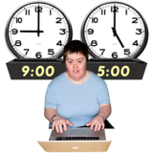 | At the moment we don’t know how often we will ask you to work.
  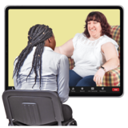 | The amount of support you will get will depend on the project you are working on.  Inclusion Gloucestershire will always contact you each month by email.  You will also be able to talk to an Inclusion Gloucestershire manager on the telephone or by video call if needed.
   | Once you have started a project, we would need you to work on it until your work is done.
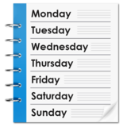  2 weeks | We will tell you about any work at least 2 weeks before it needs to be done.  You can then decide if you want to do the work.
 | You will need to reply to emails and go to meetings without support.
 | If you have a support worker, it is fine for them to help you.

