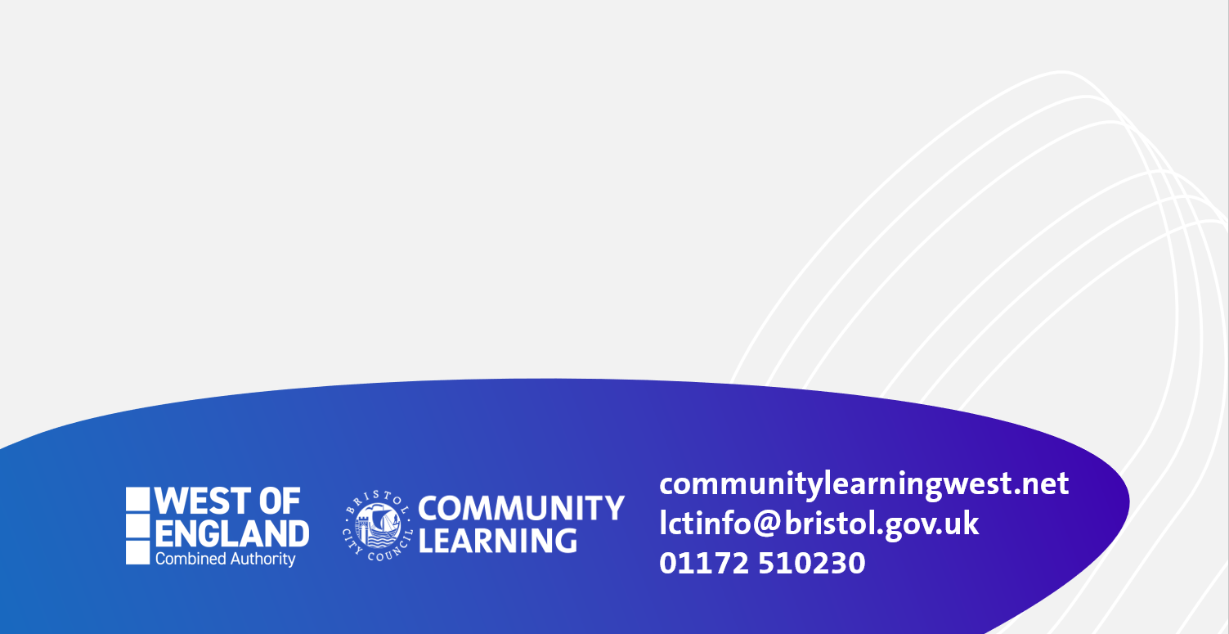

**Thurs 23rd Jan until 13th Feb, 10am –12noon**

**VENUE: The Launchpad at The Galleries BS1 3XD.**

**Develop your CV, application writing & interview skills.**

**Would you like help to improve or develop a CV? Improve your application writing and gain tips on how to present yourself at an interview?**

**This course will run for two hours each week for four weeks and focus on developing your skills in the areas above.**

**Contact:** [**Colin.young@bristol.gov.uk**](mailto:Colin.young@bristol.gov.uk)

**Phone: 07901 236 436**

**Eligibility: 19+, have few or no qualifications and earn under £23,000**

**WORK / SKILLS**